**JAVA CONTROL STATEMENTS**

1. public class LeapYear{

public static void main(String[] args) {

int year=2020;

if(((year % 4 ==0) && (year % 100 !=0)) || (year % 400==0)){

System.out.println("LEAP YEAR");

}

else{

System.out.println("COMMON YEAR");

}

}

}

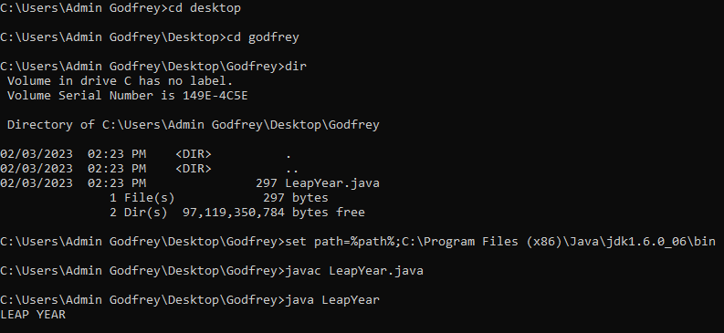

2. public class SwitchExample {

public static void main(String[] args) {

int number=20;

switch(number){

case 10: System.out.println("10");

break;

case 20: System.out.println("20");

break;

case 30: System.out.println("30");

break;

default:System.out.println("Not in 10, 20 or 30");

}

}

}

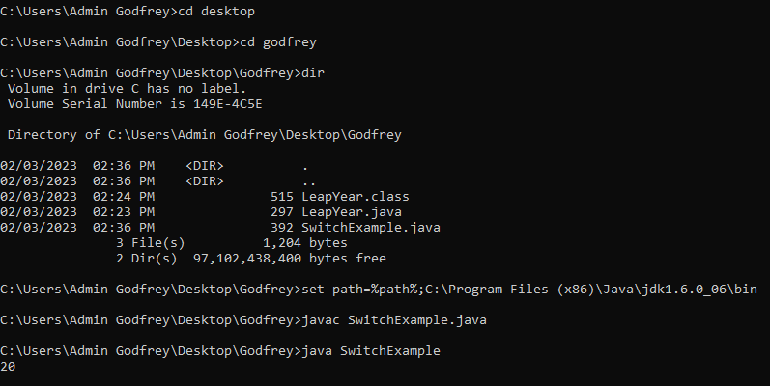

3. public class PyramidExample2 {

public static void main(String[] args) {

int term=6;

for(int i=1;i<=term;i++){

for(int j=term;j>=i;j--){

System.out.print("* ");

}

System.out.println();

}

}

}

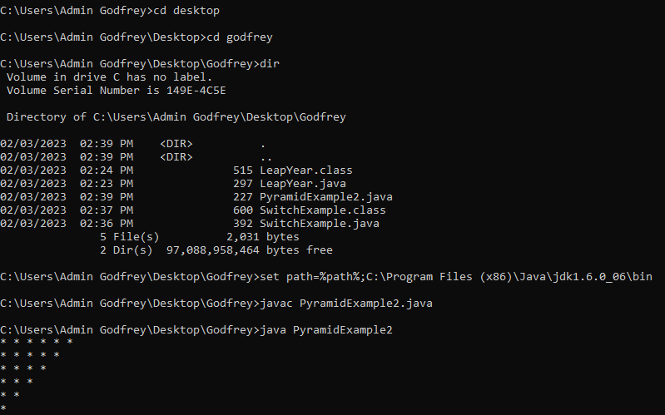

**JAVA CONTROL**

**class Student{**

**int id;**

**String name;**

**}**

**class TestStudent2{**

**public static void main(String args[]){**

**Student s1=new Student();**

**s1.id=101;**

**s1.name="Sonoo";**

**System.out.println(s1.id+" "+s1.name);//printing members with a white space**

**}**

**}**

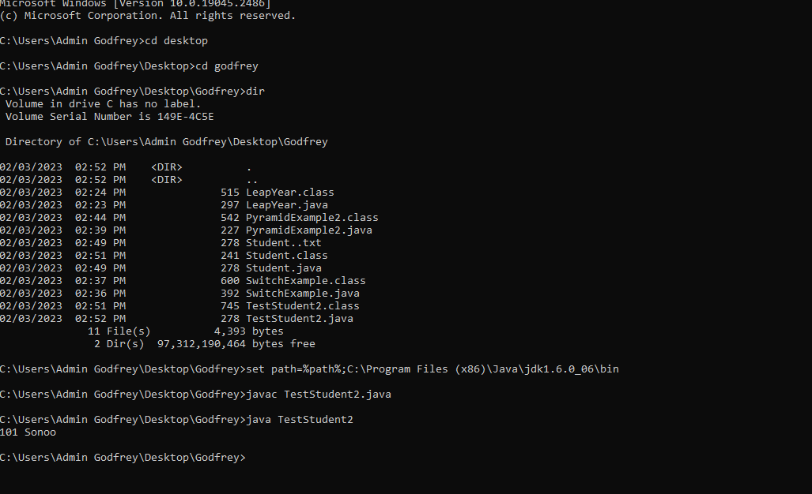

**JAVA INHERITANCE**

**1.** **class Animal{**

**void eat(){System.out.println("eating...");}**

**}**

**class Dog extends Animal{**

**void bark(){System.out.println("barking...");}**

**}**

**class TestInheritance{**

**public static void main(String args[]){**

**Dog d=new Dog();**

**d.bark();**

**d.eat();**

**}}**

